Simple Regression Part II

Problem 1 (5 points)
This problem refers to the CO2 Emissions dataset which has the following variables:
- Car
- Model
- Volume (engine size in cubic centimeters)
- Weight (kg)
- C02 (g C02/km

JMP's Fit Y by X was used to produce a scatterplot of C02 vs. Weight, and that is shown below. Identify the general shape of the three curves shown fit on the scatterplot? Only one of the answers is reasonable. Place an “X” in the box to the immediate left of your chosen answer.
Question 1: Answer Choices
 | Red = Quadratic, Green =Linear, Blue = Cubic.
X | Red = Linear, Green = Quadratic, Blue = Cubic.
 | Red = Cubic, Green = Quadratic, Blue = Linear.
 | Red = Linear, Green = Cubic, Blue = Quadratic.
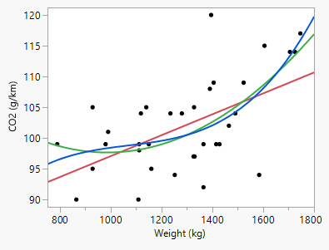

Problem 2 (5 points)
This problem refers to the CO2 Emissions dataset that has the following variables, measured on 36 different car types:
- Car
- Model
- Volume (engine size in cubic centimeters)
- Weight (kg)
- C02 (g C02/km
A 37th type was added for this problem, but you don't have access to the measurements. JMP's Fit Model was used to regress C02 on Weight for all 37 of those. Here is a table of the parameter estimates and their corresponding standard errors.
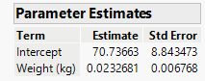
Question 2: Answer Choices
 | t = 3.862
 | t = 3.438
 | t = 1.590
X | t = 1.960
Identify the value of the t statistic that would be used to test the hypothesis shown below. Only one of the answers is reasonable. Place an “X” in the box to the immediate left of your chosen answer.
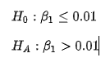

Problem 3 (5 points)
This problem refers to the CO2 Emissions dataset which has the following variables, measured on 36 different car types:
- Car
- Model
- Volume (engine size in cubic centimeters)
- Weight (kg)
- C02 (g C02/km
Question 3: Answer Choices
X | Look for common spread in vertical lines as you move left to right on the plot.
 | Look for common spread in lines perpendicular to the red line, as you move left to right on the plot.
 | Look for common spread in horizontal lines as you move bottom to top on the plot.
 | Look for an increasing, but linear, spread in vertical lines as you move left to right on the plot.
JMP's Fit Model was used to produce a scatterplot of C02 vs Weight. While this is not the way we will ultimately assess the assumption of common variance, a scatterplot works fine for a simple regression model. Specify what your eyes should be evaluating when you look at the plot if you are assessing common variance. Only one of the answers is reasonable. Place an “X” in the box to the immediate left of your chosen answer.
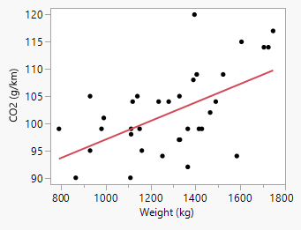

Problem 4 (5 points)
This is a background question designed to connect you to an important deliverable in Simple Regression Part II. Consider the following hypothesis of interest, where μ is an unknown population mean:
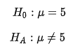
You will recall from your earliest statistics course that to test this hypothesis, you needed to know the sampling distribution of sample mean. Suppose the data being collected are a sample of size "n" from a normal distribution with mean μ and variance σ². Identify the sampling distribution of the sample mean. Only one of the answers is reasonable. Place an “X” in the box to the immediate left of your chosen answer.
Question 4: Answer Choices
 | The sampling distribution is Normal with mean μ and variance σ/n.
 | The sampling distribution is Normal with mean μ and variance σ.
x | The sampling distribution is Normal with mean μ and variance σ²/n.
 | The sampling distribution is Normal with mean 0 and variance 1.

Problem 5 (30 points)
This problem probes your understanding of what the alpha level is. Consider the following hypothesis of interest, where m is an unknown population mean:
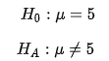
You will recall from your earliest statistics course that if you had 25 samples from a normal population with this mean of 5, and knew the population standard deviation was 20, then you’d test this hypothesis using the simplest of all tests, the z test. Here were those first-course steps:
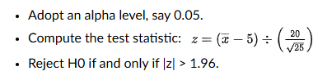
1000 samples of size 25 were produced from a normal distribution with mean 5 and standard deviation 20. You can access those 1000 samples in the file Alpha Level Simulated Samples.
Please answer each of the following questions. So that your answers remain focused, you are to include ONLY the item(s) requested (else, your earned credit will be reduced). You can use any software you prefer to do the requested calculations. However, the data is already in an Excel file so the computations would be particularly easy just left there
SAMPLE | Value of z
Sample 1 | .453
Sample 2 | -.139
Sample 3 | -.794
Sample 4 | -.753
Sample 5 | .218
- (5 points) For each of the 1000 samples of size 25, compute the value of the test statistic z. Exhibit the first five values of z below.

- (5 points) For each of the 1000 samples of size 25 and test the hypothesis of interest, recording whether the null hypothesis was rejected or not. Exhibit the decisions for the first five z values in the table below.
SAMPLE | Was H0 Rejected? (yes or no)
Sample 1 | No
Sample 2 | No
Sample 3 | No
Sample 4 | No
Sample 5 | No

- (5 points) In no more than three sentences, explain why you know H0 is true for all 1000 samples that were generated.

The null hypothesis is true because all 1,000 samples were generated from a population with a mean of 5. Since the null hypothesis states that the population mean equals 5, the population used to create the samples satisfies the null hypothesis.

- (5 points) Compute the proportion of times that you failed to reject H0 and record that in the table below.
What proportion of the 1000 tests of hypothesis failed to reject the null?
.974
- (5 points) In no more than three sentences, explain whether the number (proportion) you computed in part d. was what you expected, and why you say that.
Yes, the proportion of .974 was reasonably close to the expected proportion of .95. Since the alpha level is .05 and the null hypothesis is true, we would expect to fail to reject the null hypothesis approximately 95% of the time.
- (5 points) In no more than five sentences, explain why it was important to this problem that we were told the data generated in Alpha Level - Simulated Samples were from a normal distribution with mean 5 and standard deviation 20.

It was important that the samples came from a normal distribution with mean 5 and standard deviation 20 because these are the population conditions used for the z-test. A mean of 5 ensures that the null hypothesis is actually true. The standard deviation of 20 is used to calculate the standard error and z-statistic. Normality ensures that the sample means are normally distributed. Therefore, the calculated z-statistics follow the standard normal distribution used to determine whether to reject the null hypothesis.

